**World Spin in Public Day Celebration**

## Millennium Park Peterborough

## (beside the Silver Bean Café)

## 1-4 PM

## Saturday September 16, 2017

Join the Peterborough Handweavers’ and Spinners’ Guild in celebrating the craft of traditional hand spinning fiber into yarn!

Demos and free “try-it” sessions.

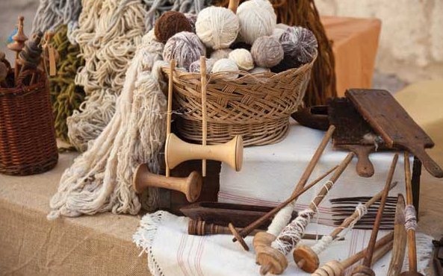For information, contact Anne Gallant at annegallant@trentu.ca.